MUSICAL QUIZ
WIN Champagne * Highland Park Whisky * Chocolates and prosecco
*£50 voucher for Orkney goodies from jporkney.co.uk
Correct entries will be entered into a prize draw

TO ENTER:
Download, click on 'enable editing', type in the answers, save it and email to: malawimusicfund@gmail.com OR print, complete by hand and post to MMF Quiz, Easdale House, Easdale Loan, Kirkwall, Orkney, KW15 1RU.
Please make a donation to Malawi Music Fund via our website: www.malawimusicfund.org.uk or by enclosing a donation with your entry.
Your donations will help us support the education of orphaned children in Malawi.
CLOSING DATE: FRIDAY 4TH SEPTEMBER.

Name: |  | Email:
Telephone:

I have made a donation | Online | Enclosed
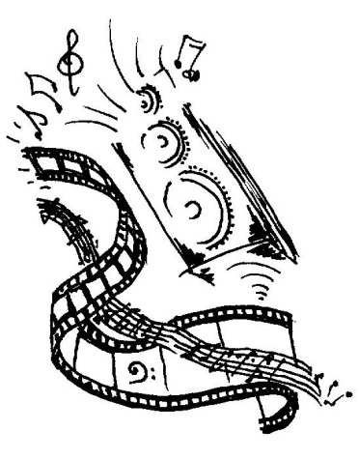
MOVIE MUSIC

- ‘Play it, Sam’, says Ingrid Bergmann in the classic film Casablanca. What tune does she want Sam to play?

- Name the 1973 Academy Award-winning film that featured ‘The Entertainer’ by the ‘King of Ragtime’ Scott Joplin.

- Paul McCartney and his band Wings performed the title song of
which James Bond film?

- In the song ‘Maria’ from the film West Side Story, how many times does Tony sing the name ‘Maria’?
- A composer of over 500 film scores including The Mission, Cinema Paradiso and many ‘spaghetti westerns’ died in July. Who was he?
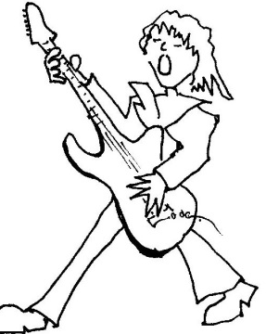
POP and ROCK
According to their songs …
- Where were Status Quo rockin’?

- How many little birds did Bob Marley have no worries about?

- Dire Straits were the Sultans of what?

- The Sex Pistols wanted what ‘in the UK’?

- What did ‘daddy take away’ in the Beachboys’ song?
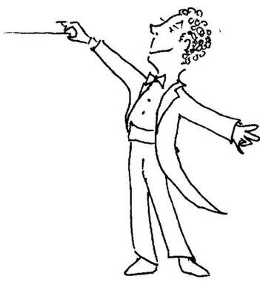
ORCHESTRAL AND CHORAL
- Which conductor has won more Grammy awards than any other musician?

- The three orchestral works have something in common:
Robert Schumann, Symphony No.3 in E flat major
The 2nd movement of Bedrich Smetana, Ma Vlast
Edward Elgar, Enigma Variations, the 11th variation
What is it?

- Something links these compositions:
a 1983 work for solos guitar by Michael Tippett
a 1939 piano concerto by Xian Xinghai
a 1741 set of variations for harpsichord by J. S. Bach
What’s the link?

- Match the following composers with their non-musical interests.
For Trainspotting enter 1, for Astronomy enter 2, and for Painting enter 3
Saint-Saëns
Mendelssohn
Dvorak

- Which 1962 large-scale work for choir, boys’ choir, orchestra, chamber orchestra, organ and vocal soloists sets poems by Wilfred Owen alongside Latin text?

MUSICALS

- According to the cast of Rent, how many minutes measure a year?

- Broadway actress Lea Salonga played the role of Fantine in Les Misérables’ 25th Anniversary Concert in London. Which character did she portray in the 10th Anniversary London Concert?

- Which film musical was based on a story by James Bond creator Ian Fleming and adapted by children’s author Roald Dahl?

- In which musical did Judy Garland sing the song made famous by Frank Sinatra, ‘Have yourself a merry little Christmas’?

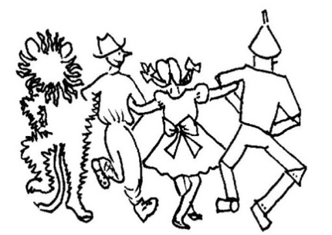
- How frequently does the mysterious Scottish village of Brigadoon appear?

OPERA
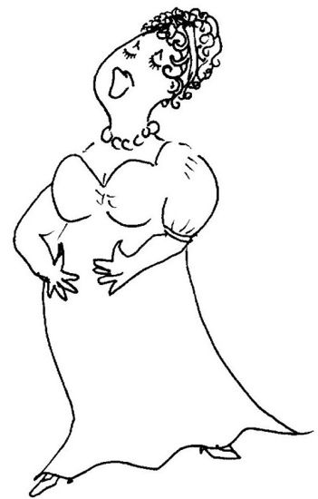
- Which Mozart operas have:
  - ‘’too many notes’’?
  - a libretto based on a revolutionary play by Beaumarchais?
  - a part for the glockenspiel?

- Who composed:
- The Barber of Baghdad?
- Abu Hassan?
- The Goose of Cairo?

- Walter Scott novels have inspired many operas. Give the titles of the operas based on the following and name the composers of each.
- The Bride of Lammermuir
- Ivanhoe
- The Fair Maid of Perth

- In which Puccini operas do the following minor characters appear?
- Benoit, a landlord
- Goro, a marriage broker
- Ping, Pang and Pong

- In which operas do the following non-singing characters appear?
- Tadzio (danced)
- The Major-Domo (spoken)
- Duncan (silent)

BACH to Basics ……..

- J. S. Bach was born in 1685, the same year as Handel and one other composer.
Who was he?

- Which of J. S. Bach’s sons was known as the ‘English Bach’?

- 1705 Bach went off to hear another organist. He had a few weeks’ leave but did not come back for several months. Who was the organist he went to hear?

- J. S. Bach wrote the Orgelbüchlein. What does this translate as in English?
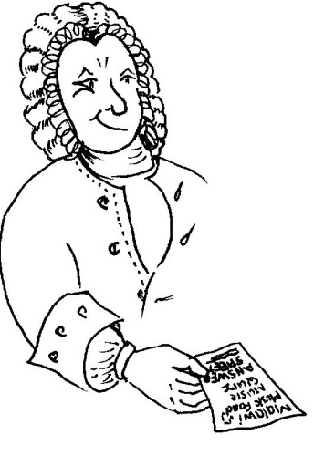
5. Peter Schickele, an American music satirist, ‘discovered’ the works of Bach’s only ‘forgotten son’. What did he claim the son’s name was?

THANK YOU FOR TAKING PART!

